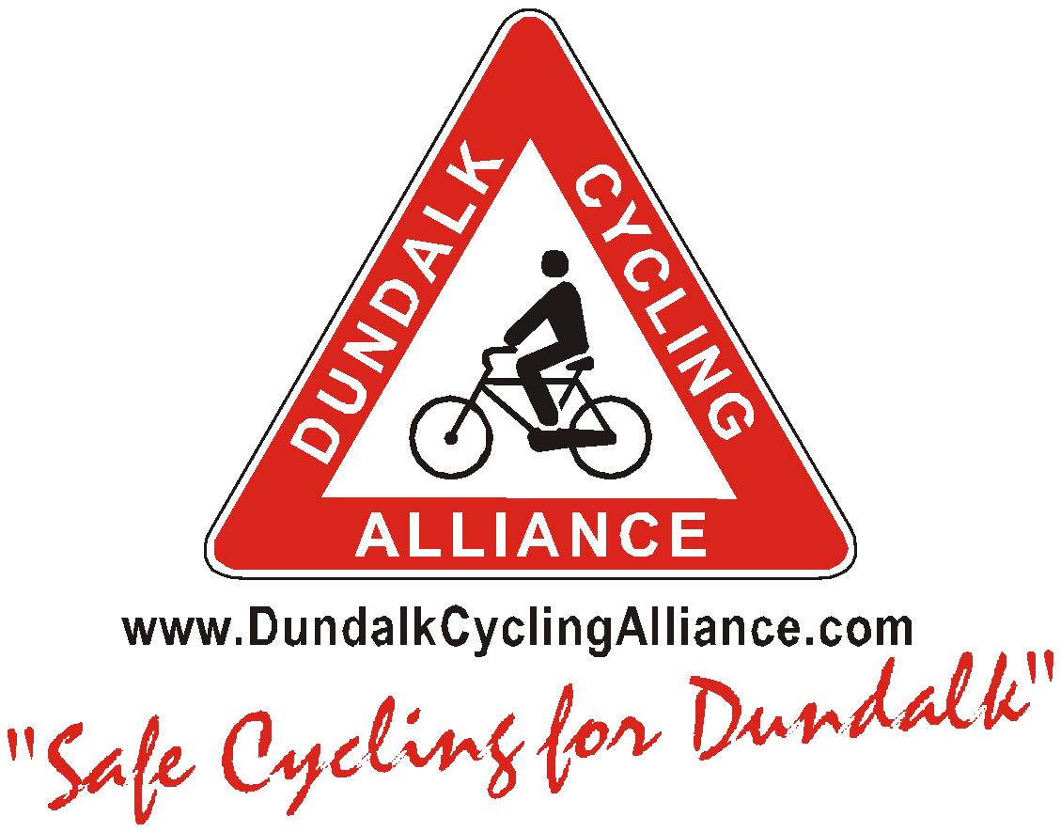
editorial@argus.ie
Letter to the Editor
25th Feb 2017.

Coláiste Chú Chulainn is now under construction but will the students at this school learn the lessons and the healthy habits of “Operation Transformation”?

Dear Editor
I understand that Louth County Council is primarily in charge of building the new Gael Scoil, Coláiste Chú Chulainn. The Council has a budget for the school of €16 million. Will the Council Executive continue to withhold funding for the completion of the new cycle ways to schools or will the necessary spending be made to encourage the students to adopt a healthier active lifestyle?

RTE’s “Operation Transformation” has been running for weeks now with a message of healthy diets and healthy physical activity. Over the last weeks the nation has been watching a small group of inspiring people trying to change away from the lethargic lifestyle habits that was slowly killing them. On TV we have been watching these people out walking and running with friends every evening.

Likewise when the new Gael Scoil is built, will regular daily exercise, 5 days a week, become a normal regular activity for many of the students? On the trip to and from Coláiste Chú Chulainn will students and teachers be likely to develop the 30 minutes of moderate exercise that is recommended as a matter of habit? We believe that the Local Authority in Louth must play their part in Operation Transformation. The Local Authority must properly finish the presently incomplete safe cycleway for walking and cycling to the new school.

For example, there are at present no ramped zebra cycleway road crossings near the location of the new Coláiste Chú Chulainn. Students will have to cross the busy Marshes Avenue to get to the Marshes Shopping Centre. There is no ramped zebra crossing at the roundabout between An Bóthar Iarainn and the Marshes Avenue. There is also a very badly positioned ramp at the traffic light crossing at Aldi on the Ramparts Road that needs to be re located. The space between the traffic light and the stone wall of the supermarket is too narrow.

Public transport maps showing the various destinations along the present traffic protected cycle way from Tom Bellew Avenue past the new school and into town are needed at strategic points along the existing cycleway. We see advertisements on TV every day to use cars to drive our children into school. I believe however that we need to be much more serious about reminding people / marketing the health advantages of cycling to schools. Big cities around Europe make information available on various public and sustainable transport options. Dundalk likewise should certainly provide public maps of the few good cycle way routes that we already have.

The public health experts are in no doubt – becoming lethargic in youth can lead to big problems for a person’s health in later decades. Unless the Council spends money today to instil the habit of being physically active; it may be much more difficult for our young people to develop or maintain an active healthy lifestyle, later on, as they become adults.

Regards Ollan Herr
On behalf of “Dundalk Cycling Alliance”

