

**Submission to the Public consultation on National Clean Air Strategy**

4th May 2017

**A submission calling for legislation to ring fence budget of at least 10 % of each council’s total transport budget to be spent on improved infrastructure for zero emission transport.**

We in DCA advocate investment in cycle ways to schools to reduce the air pollution from car traffic in the mornings and later on in the evenings during the working week will contribute to better air quality in urban areas.

We advocate this modal switch from car to bicycle and walking will reduce the number of car journeys and hence will directly cut our road traffic emissions.

Integrated contiguous cycle ways from where the students live to where they go to school are required. Other schemes such as road crossings to schools and funding for bicycle route signs are also required. (See attachments 1 and 2.) These signs can be of the type used in London or of a simpler design attached to existing poles along the route. We also recommend the use of large signage at strategic points in the centre of towns and on all major access roads to show the extent of the cycle ways in each town. ( See attachment 3.)

We would also suggest that issues sounding “matched funding” be resolved because even when a Council can apply for some funding streams which may require matched funding that they do not have the finance available to draw down these funds.

 We request that 10% of the total roads budget should be spent on non fossil fuel, alternative transport methods such as safe cycle ways to schools – so that the air in towns like Dundalk will be less polluted and safer to breathe. Our experience in Co. Louth has indicated to us that the county manager will be required by legislation to make this budgetary allocation given the recent budgetary constraints. This is a matter of public record. We suspect that the same may be true in other counties.

Tony Lennon

On behalf of Dundalk Cycling Alliance

<http://dundalkcyclingalliance.com/>

48 Willow Grove.

Carrick Road.

Dundalk.

Co. Louth.

Appendix 1

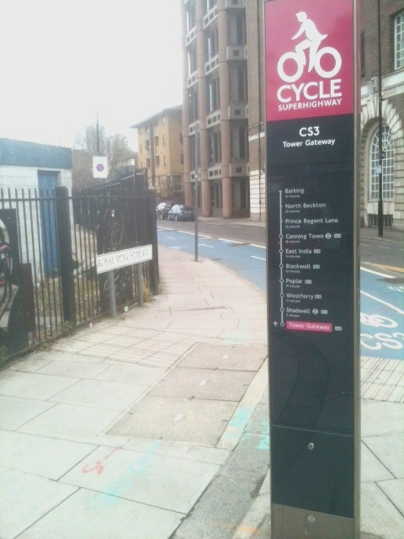

Example of a London cycle route sign.

See separate document for appendices 2 and 3.