Letter to the Editor - Dundalk Democrat

David Lynch



Phone: 042-9395608  
Email:david@dundalkdemocrat.ie

**Residents at Ath Lethan support calls** **for a safe road crossing to join up disconnected cycle ways at the Táin bridge**

Dear Sir

Dundalk Cycling Alliance Chairman Mr Liam Kieran presents the 130 signatures from the residents of Ath Lethan to Councillors Peter Savage and Mark Dearey. The residents are supporting proposals for a safe pedestrian and cycling road crossing at the Táin Bridge. This safe crossing would join the cycleway that runs through the linear park along the northern side of the Castletown River to the existing traffic protected cycleway that runs from the Táin Bridge to the Racecourse and Ath Lethan. Many Ath Lethan residents have reported that it is too dangerous at present to attempt a crossing with young children along this very fast busy road. One resident in particular described crossing the road at the Lidl Shopping centre as a death trap.

Liam Kieran explained that the funding of this safe road crossing would complete the various start-stop cycle ways that already exist in this area of Dundalk. This is necessary if we want to encourage younger and older people to cycle to local schools and shops.

Councillor Mark Dearey said that this road crossing would also offer the possibility of re-opening the old railway line for walking and cycling from the Táin Bridge to the Flurry River and onwards. This he claims would become a wonderful amenity for cycling from Bellurgan and Lordship to town along the old railway, using a new bridge across the Flurry River

Mr Kieran of the Cycling Alliance claimed that their group have already been successful in originally proposing the new cross border cycleway that is to be built from Omeath to Newry. Presentations had been made by the DCA to The Newry and Mourne Council in the months before the EU Intereg Funding was officially announced he said. This proved to be a positive factor for quickly establishing the close co operation that now exists with Louth County Council for this cycling project. People will soon be able to cycle from Newry to Omeath and to Carlingford. The Cycling Alliance believes that this cycling route should be continued from the Táin Bridge the whole way around the Cooley Peninsula.

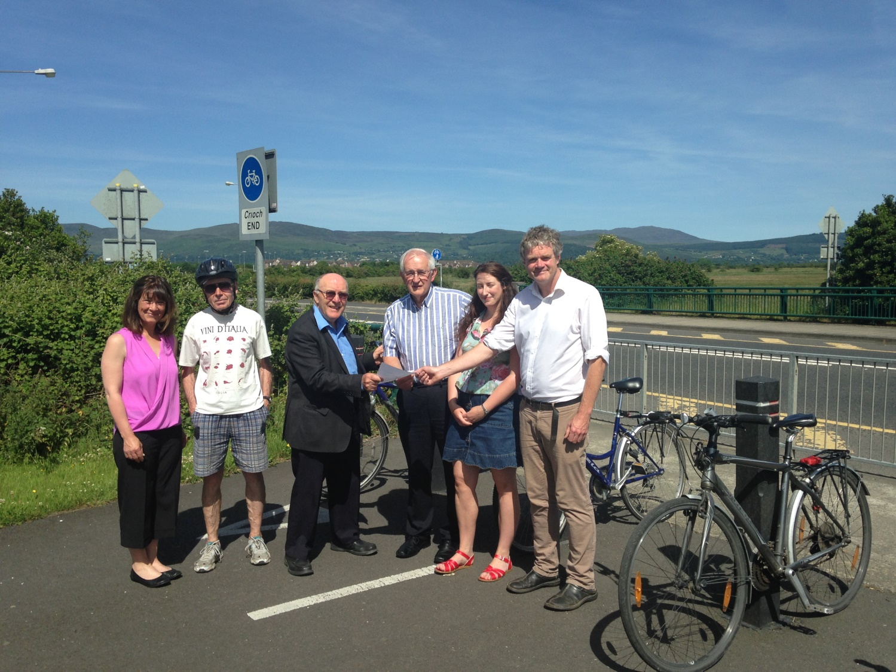

Fiona mc Grath, Pat Mulholland, Liam Kieran Chairman of the DCA, Councillor Peter Savage, Saoirse Brophy Green Schools Education Officer and Councillor Mark Dearey at the Táin Bridge

Councillor Peter Savage has already been active this past 12 months with the Local Authority road engineers on this matter. He has explained to the engineers already the need for traffic calming on this road and the need to connect these cycle ways using safe road crossing. Small funding is all that is needed for this project. It is so important that residents should be able to cycle safely along the whole route from Ath Lethan to the nearby local schools and shops.

End

