Sustainable Transport Division,
Department of Transport, Tourism & Sport,
Leeson Lane,
D02 TR60.

Dear Sir.

This agreed submission is made on behalf of the Dundalk Cycling Alliance.

Regarding the financing of major projects we in the DCA feel that these projects should be 100% centrally financed. Small County Councils like Louth do not have the financial resources to make a reasonable financial contribution to major projects.

Monies for smaller projects must be ring fenced for cycle way development.

In this submission there are several references to a proposal for a Great Eastern Greenway. We in the DCA would be delighted to forward to you our proposal for this project.

Regards

Tony Lennon
11th July 2017

48 Willow Grove,
Carrick Road,
Dundalk,
Co Louth,
A91 V8 C9.

Specific Questions Raised in the Consultation Paper for Consideration:

Benefits of Investing in Greenways? (page 13)
Q1 Do you agree that the State should invest in greenways?
- It is imperative that the state invests in greenways for:
  - Economic benefits through:
    - Tourist income.
    - Cycle ways create local sustainable jobs. For example on the Newry Canal Towpath there are two cafes one which is 100 meters from the towpath and at least 50% of its income is derived from the tow path users the whole year long. Another café is actually on the tow path approximately 5 km from the first and looking at its clientele has an even higher income from the towpath.
    - Less fuel purchased as a result of modal shift to recreational cycling and utility cycling.
  - Physical and mental health and wellbeing of our citizens and particularly the youth of the state.
  - Greenways will contribute to our carbon reduction commitments through modal shift for both commuters, general utility cycling and recreational cycling. This is particularly important as it now seems likely that Ireland will miss its agreed targets for carbon reduction.
  - The greenways provide a safe environment for our children to learn to cycle with confidence before starting utility cycling.

Q2 What do you consider to be the most important benefits that greenways can deliver in Ireland?
- Economic benefits.
- Physical and mental health benefits.
- Carbon reduction.
- Cycling improves the health of those who cycle and also improves the health of those who breathe the less contaminated air as a result of reduced car usage.

Q3 Are there benefits to be derived from greenways other than those set out above?
- More emphasis should be put on climate change and modal shift resulting in carbon reduction to meet our carbon reduction targets.

Q4 What benefits should be given primary consideration when considering investment in future greenway projects?
- Local recreation.
- Local commuters and utility cycling.
- Inbound tourist revenue.
- Intra-national tourism i.e. Irish people staying in Ireland for their vacations.
- Integrated cycle ways with maximum access for large number of users.
- Integrated cycle ways provide weekend destinations as opposed to day trips of non-integrated isolated cycle ways.
- The DCA is proposing the creation of an integrated Great Eastern Greenway to complement the Great Western Greenway. This will include the existing Portadown to Newry Towpath and the and existing and approved stretches of greenway as far as Carlingford. An extension from Carlingford to Dundalk continuing on to Drogheda and eventually to Dublin is proposed by the DCA.( We would hope that it would be continued from Portadown to Belfast!)
- One thing that must be considered is Community. The cycle way develops a community of its own which contributes to the wellbeing of its users.

Q5 Should the State invest in greenways that do not offer the full range of benefits set out in this Chapter, e.g. greenways that do not offer real potential to develop tourist/visitor interest but provide a local recreational facility?
- To get the max tourist revenue both inbound and local tourist revenue we should invest in integrated greenways. This also applies to maximizing the total number of users.
- Urban greenways should link places of work, recreation and life for example a greenway from Dundalk to Blackrock built along the coast. However this is still part of the overall Great Eastern Greenway. This will facilitate recreation and in particular commuter /utility cycling.

Consultation (Page 14)

Q1 How should local authorities and/or other greenway project developers engage with local communities on greenway proposals?
- For rural greenway projects there should be consultation with local community groups and public representatives. With rural routes there are usually more alternatives to consider so it would be hoped that agreement would be reached more easily.
- For urban routes inserting the route into the pre-built urban environment presents more difficulty and so more consultation at earlier stages in the process is required. This must be done in such a way as to convince rather than coerce those who feel threatened by urban cycle networks.

Q2 What level of consultation should take place and at what stage should this be initiated?
- We should follow our existing procedures and identify how they can be improved.

Q3 Is consultation as part of any statutory requirements sufficient?
- No. Earlier broad consultation process is required.

State owned land (Page 16)

Q1 Should local authorities and/or other project developers seek to use State - owned lands, where possible, for the development of greenways?
- State owned lands should be used where possible.

Q2 Are there reasons why State - owned lands should not be used for the further development of greenways in the State?
- There are no obvious reasons why State owned lands should not be used for greenways.

Q3 Are there particular types of State - owned lands that would not be appropriate for the development of greenways? If so, why?
- Lands that are too remote with limited scenic potential or limited utility cycling potential.
- Safety and other issues such as lands in proximity to unpleasant environment e.g. sewage works.
- Where a better way via different route may exist on lands that may not be in state ownership.

Q4 How can the synergies between ‘blueways’ and ‘greenways’ be maximised to provide most benefit to the future development of outdoor recreational infrastructure in the State?
- An integrated network of blue-ways and greenways should be created.
- Network of facilities with maximum interconnection to transport infrastructure e.g. airports, sea ports, railways, and roads will maximise the use of these facilities.

Permissive access (Page 17)

Q1 Is the permissive access model an appropriate basis for the future development of greenways in the State?
- Permissive access is a good model which is working and should continue to be used.

Q2 Permissive access arrangements can avoid potentially expensive land acquisition costs in the development of greenways but are there other benefits to using this model that would render it more appropriate in certain circumstances?
- There are always alternative routes to bypass uncooperative landowners.
- If we change to land purchase it would increase the costs of greenways.

Q3 What type of greenway projects would permissive access be suitable for?
- Rural blueway and greenway routes.

Q4 Are there projects that permissive access would be unsuitable?
- Some urban routes may be compulsory purchased to bypass obstructions where no other suitable routes may be available through the built environment.

Compulsory Purchase Orders (Page 18)

Q1 Where a proposed greenway route involves access to privately owned land do you think that CPO is a valid mechanism for the acquisition of land on a route?
- Where no Permissive Access is available a CPO is valid however this raises the question for the rest of Permissive Access Agreements already in place.
- A CPO may be required in urban Greenways where alternative routes may not be possible.

Q2 If you don’t think CPO is valid, what alternatives would you suggest?
- Permissive Access Agreements should be used where possible as the precedent has already been set.

Q3 At what level should consultation take place with landowners where CPO is being considered - at the individual landowner level or with representative bodies?
- Use whatever model is currently being used by the National Roads Authority.

Network Approach (Page 20)

Q1 Should the concept of the National Cycle Network as proposed in the 2010 NCN Scoping Study be developed or set aside?
- To maximise the tourist revenue potential the network should be interconnected.

Q2 Is it appropriate for the State to invest in individual greenway projects that may never have potential to connect to other greenways or substantially off - road cycle facilities?
- It is more appropriate to establish an interconnected network of rural and urban greenways.

Q3 Should the Greenways Strategy aim to develop a network of interconnected greenways or should alternative approaches be considered?
- The Greenways Strategy should aim to develop a network of interconnected greenways with a network of ancillary loops rather than just spurs if possible.

EuroVelo (Page 23)
Q1 Do EuroVelo 1 and EuroVelo 2 offer an approach for the development of greenways and other cycle routes in Ireland?
- Expansion of EuroVelo 1 &2 Belfast to Dublin along the costal route as proposed by the Dundalk Cycling Alliance (not along the old N1 route).

Q2 Do you have experience of cycling on a EuroVelo route on continental Europe?
- No.

Q3 Do you think the development of EuroVelo routes in Ireland would help to increase cycle numbers?
- The EuroVelo routes in Ireland would increase tourist cycle numbers on appropriate routes. – e.g. the DCA proposal for the extension of the Portadown to Carlingford route to Dundalk and on to Drogheda and eventually to Dublin.

Q4 Should the focus of the Greenways Strategy be on greenways in the strictest sense (fully or substantially off - road) or should the use of lightly - trafficked roads like those on EuroVelo routes also be considered if a ‘network’ approach is to be taken?
- For recreational cycling it depends on the traffic volumes:
  - On busy roads even curb separated cycle ways is a totally unpleasant experience and is not suitable for recreational cycling.
  - On low traffic roads (by the sea) joint usage may be acceptable provided ample signage, speed humps and passing points are provided. An example of this is on the Newry Canal Towpath there are sections which are greenway and sections which are dual use. In fact dual usage is being recommended a part of a mixed solution particularly on the proposed route from Dundalk to Drogheda.
- For Utility Cycling:
  - The emphase should be on curb segregated cycle ways and urban greenways.

Q5 What role, if any, should EuroVelo routes play in the Greenways Strategy?
- To support local use of as a method of developing inbound tourists cycling but not to the exclusion of all else.
- The expanded EuroVelo routes will provide a valuable marketing asset.

Urban Greenways (Page 24)
Q1 Should the Greenways Strategy address the development of urban greenways or should these continue to be pursued in the context of urban Transport Strategies as referenced above?
- There is no reason why urban greenways should not form part of the urban cycleways like the Barclays system in London where the physical space exists.
- However the existing built environment in most towns and cities in Ireland may make this particularly challenging.
  - An example of a challenging but very popular route urban greenway route would be from Dundalk to Blackrock. – This will require stretches of a Boardwalk to be built along the sea wall because of the lack of space on land and the lack of suitable alternative routes however when built it will be of great benefits for recreation and commuter cycling. This cycleway would go along the coast from Blackrock towards Dundalk. There would be a spur linking to the cycle ways on the inner relief road for the commuters or to the Dundalk schools. Alternatively, the recreational cyclist could continue along a route towards Soldiers Point possibly on top of the embankment.

Standards and Accessibility (Page 25)
Q1 What type of surface should be used on Greenways?
- The surface should be “Black top”.
- The argument for compressed stone to slow down cyclists is spurious. My experience from using a black top and observing racing bikes, hybrid bikes, high nelly’s, disabled bikes, and pedestrians all using the cycleway is that everyone is very respectful of other users.
- Black Top would also facilitate mothers with buggies and wheel chair users.
- To encourage commuters to use these facilities they will require Black Top. At commuter rush hours the cyclists may want to cycle a bit faster than at other times of the day. There are usually not too many recreational walkers out between 07:00 and 09:00 o’clock in the morning!
- Another possible reason for using Black Top is that Black top could be viewed as a lifetime product whereas compressed stones may require more maintenance.
- The Black Top surface must be a well laid smooth surface. There are some curb segregated cycle lanes where the surface undulates so much that they are unpleasant to cycle on so cyclists cycle on the road instead!

Q2 Should different areas (rural/urban) have different surfaces?
- The same quality of surface should be available for all. The DCA sees no reasons why rural and urban cycle ways should have different surfaces.

Q3 Should access be controlled or open?
- Access should not be blocked by gates etc.
  - Access required for mothers with double buggies.
  - Access required disabled persons including disabled trikes.
  - Access required recumbent trikes etc.
- Chicanes are an anathema to cyclists and should not be used.
- Cyclists often try and go through them without dismounting and could easily injure themselves.
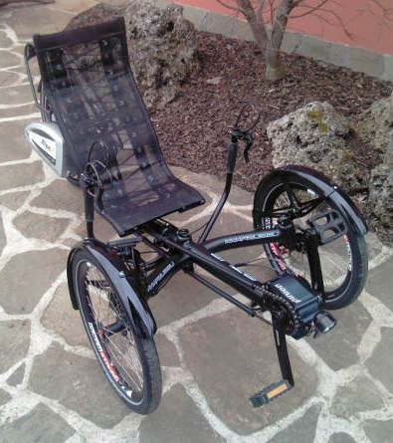
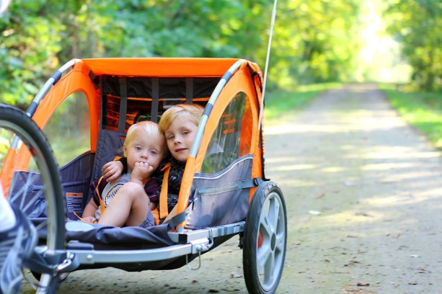
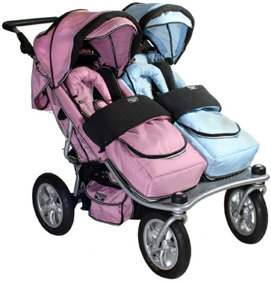
- To stop quad bikes use simple poles with a separation of one meter while permitting the smooth passage of cyclists, cyclists with children in trailers, recumbents bikes and recumbent trikes, mothers with twin buggies, disabled trikes, and people in wheel chairs.

